**1. In two to three sentences define and explain each theme of geography.**

I. Location

A place defined by its latitude and longitude. Also a relative location

II. Place

Place describes the human and physical characteristics of a location. This includes things such as mountains, rivers, and other landforms. Also things like the climate and life there.

III. Human/Environment Interaction

How humans adapt to and modify the environment. We shape areas of land through our interaction with it, such as driving and walking. This has both positive and negative effects on the environment.

IV. Movement

This describes how we as humans move goods, resources communication, and migrate across the Earth.

V. Region

A unit on Earth’s surface that has characteristics such as climate or industry. We study not just about the region, but also how they can change over time.

**2. Give two personal examples from your life for each theme.**

I. Location

A) I live in Provo Utah.

B) My address is 1412 Timpanogos Dr.

II. Place

A) I live in the Rocky Mountains.

B) I live next to Provo River (if you can call it a river).

III. Human/Environment Interaction

A) I go hiking which can change the mountainside.

B) I like to go off-roading in a jeep which can change the paths we take.

IV. Movement

A) I buy imported products off the internet, and also foods that may be imported.

B) When I go on vacation I am moving.

V. Region

A) I live in the Rocky Mountains

B) I live in The West

**3. In two to three sentences, explain in your own words why geographers have developed the Five Themes of Geography**

They made the Five Themes to be able to aid us in studying all sorts of issues, both local and global.

**4. Find Pictures that represent each theme.**

**5. Copy and paste each paper into your assignment**

**6. Next to the picture, explain what theme is being represented. In three to four sentences how and why it represents that theme.**

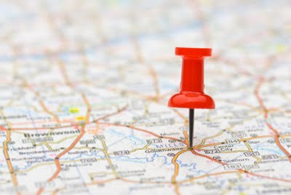

Location

This represents location because there is a map. There is a pin on that map to show a specific location.

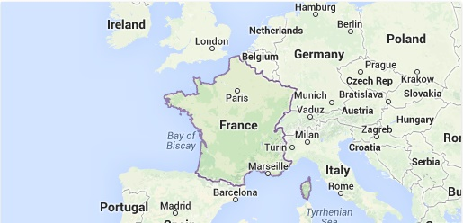

Place

This represents place, because place is very general. It can be anything that you’re included in, in this case France.

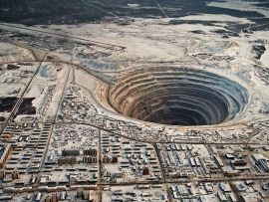

Human/Environment Interaction

This is Human/Environment Interaction because this hole may have destroyed many animals homes, forcing them to move to other locations.

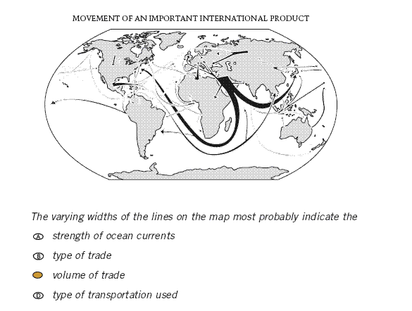

Movement

This displays movement because it shows how and where things are transported.

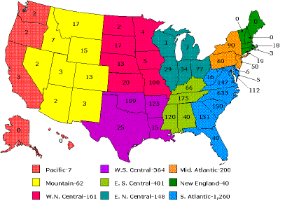

Region

This shows region because it shows areas that don’t have specific boundaries. Different people have different ideas of what regions there are, and what states are in them. This is one person’s idea of US regions